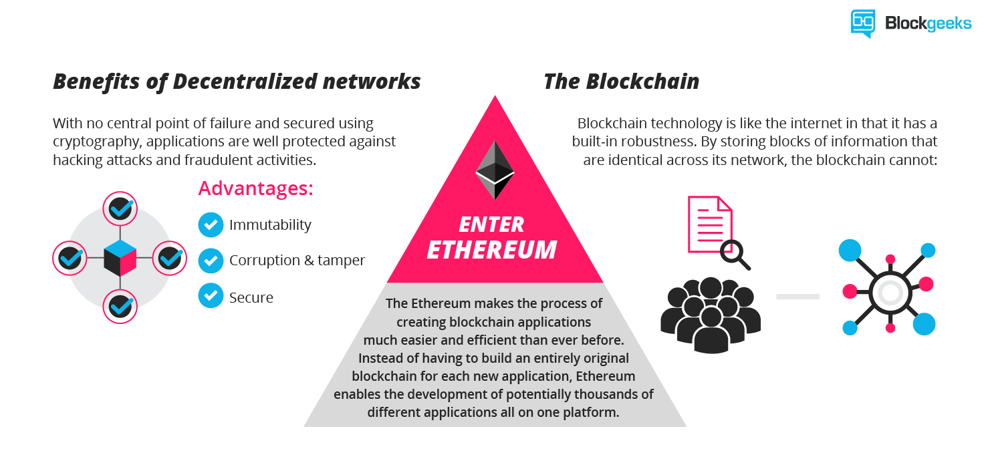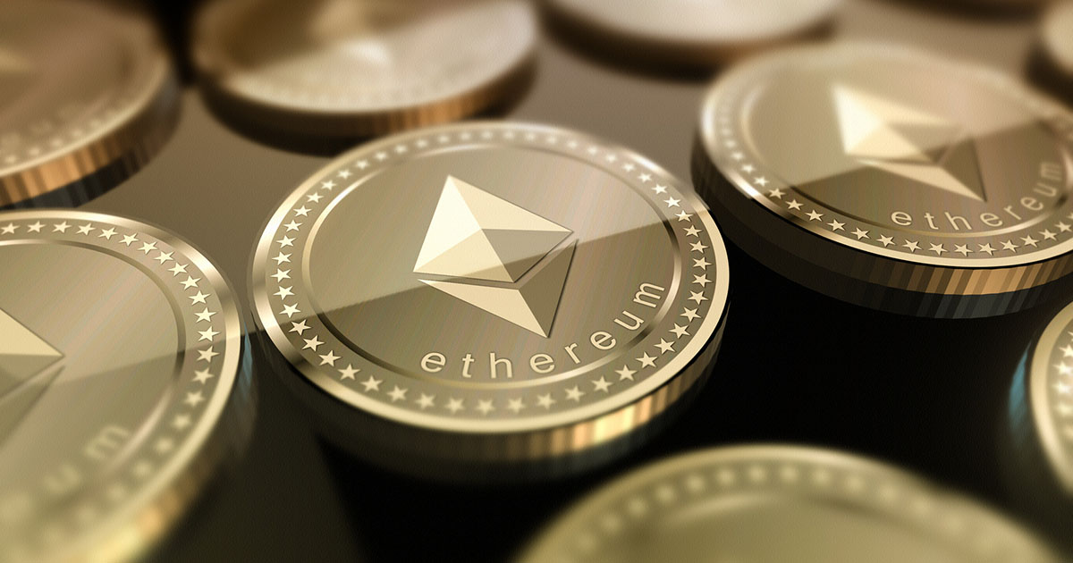**How to Use Ethereum**

The thought of using ethereum might sound intimidating, but it could be rewarding.

If the 'unstoppable world computer' develops according to plan, it could provide alternatives to the Facebooks and Googles that many people use everyday (as explained in "[What is Ethereum?](https://www.coindesk.com/information/what-is-ethereum/)").

Ethereum might not be as intuitive as the web as we know it today, but still, anyone with a computer or a smartphone can try the platform out as long as they own '[ether](https://www.coindesk.com/information/what-is-ether/)' – unique pieces of code that allow updates to the blockchain's ledger.

**Ethereum wallets**

First, you need a place to securely store your ether (or at least a place to store your private keys). This brings us to ethereum 'wallets'.

One caveat is that losing your private key is a much bigger deal than misplacing a password: it means losing your ether, forever.

Removing trusted parties is a two-edged sword. While intermediaries are no longer needed to verify transactions, there's no help desk to turn to for help recovering your secret key.

With that in mind, there are plenty of options for wallets to store cryptocurrency: desktop wallets, web wallets, hardware wallets and paper wallets.

Choosing one depends on your preferences for convenience and security. Usually these two concepts are at odds with one another: the more convenient, the worse the security (and vice versa).

**Desktop wallets**

Desktop wallets run on your PC or laptop. One option is to download an ethereum client (a copy of the entire ethereum blockchain). There are a few ethereum clients written in different programming languages and with different performance tradeoffs.

This process can take up to a couple days, and will only increase as ethereum grows. The wallet then needs to stay in sync with the latest transactions on the blockchain.

**Mobile wallets**

Mobile clients, or 'light' clients, require less data to be downloaded to connect to the network and make transactions, so they are more suitable for download to a smart phone.

The light client option is more convenient, but not quite as safe. Full ethereum clients offer a more secure way of receiving transactions because they do not need to trust miners or nodes to send them accurate information – they validate transactions themselves.

Storing private keys on a device that is detached from the internet (a method known as 'cold storage') is harder to hack and is best used for storing large ether holdings.

However, the method is not as easy to use as when ether is stored on a smartphone or internet-connected computer.

**Hardware wallets**

Hardware wallets, which are often as small as a finger or two, arguably offer the best of both worlds. These secure devices that can often be detached from the internet, and can sign transactions without being online.

But again, this deposit-box-like system is not a good option if you want to use ether frequently or on the move.

**Paper wallets**

Another cold storage option is to print or carefully handwrite a private key on a slip of paper, a 'paper wallet', and lock it somewhere secure like a deposit box. Online tools can generate key pairs directly on your computer – not on a website's servers, which could leave keys vulnerable if the site is hacked.

It's also possible to generate keys using the command line, provided you have the necessary cryptographic packages installed for your preferred language.

All that said, again, if you lose your private key, it’s gone for good.

So, best practice is to spend some extra time creating multiple copies of the private key and stashing them in different secure locations, in case one is lost or destroyed.

**Buying ether**

Obtaining ether varies by country, or at least by currency. You need to find someone either online or in-person who has ether and wants to trade.

There’s always the option of meeting in-person to buy or sell ether, especially if living in a city with frequent ethereum meetups, such as New York or Toronto.

That’s not always an option in less populated areas. Exchanges allow users to buy ether directly with dollars or bitcoin. Typically there is a sign-up process.

Buying ether with another currency might take an extra step.

Bitcoin is the most commonly used cryptocurrency, and people around the world are more likely to want to trade for it in their currency. So, if you want to buy ether for rubles, for instance, the easiest way might be to purchase bitcoin at an exchange and then trade that for ether.

Once you have ether, you can send it directly to another person ('peer-to-peer'). It will likely cost a small transaction fee paid to miners.

**Now what?**

What can users do once they have ether?

You may have noticed that the wallet and exchange lingo up to this point has been quite similar to bitcoin. But ethereum applications are quite different.

Users with ether can join or create smart contracts (code that automatically executes the terms of an agreement so that you don’t have to rely on a third party).

Bundles of smart contracts can be used to create decentralized applications ('dapps'), which you can use or join.

**What's the system?**

But before we go any further, it's worth explaining a little bit about how it works. Ethereum and other cryptocurrencies have an admittedly confusing storage system.

Perhaps it's useful to compare it to what we already know.

Notice the string of numbers on the front of your credit card? It's necessary for banks to determine where they should send money when the card is swiped. Cryptocurrencies allow you to generate similar identification numbers that identify where to debit funds.

In this system, there are two main components that users need for identification: the public key and the private key. Usually represented as a scrambled string of numbers and letters, the two keys are linked together by cryptography.

The public key can be sent to others so that they know where to send your money. If you want people to send you ether, you need an address: a scrambled string of letters and numbers derived from the similarly scrambled public key, for people to send coins to.

To spend ether, you need to sign over the funds with your private key, which, as the name implies, is similar to a password. In the credit card analogy, it’s similar to the pin used to unlock your funds at the ATM or in a store.

So, what’s the benefit of this system? One key difference in open blockchains (such as bitcoin and ethereum) is that users can generate an identification number for their funds at any time. They don’t need to wait for a bank to approve a bank account application and present the credit card.